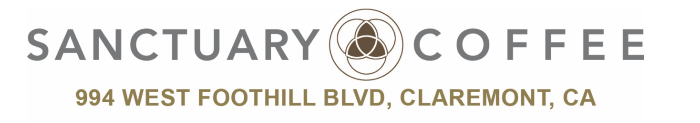
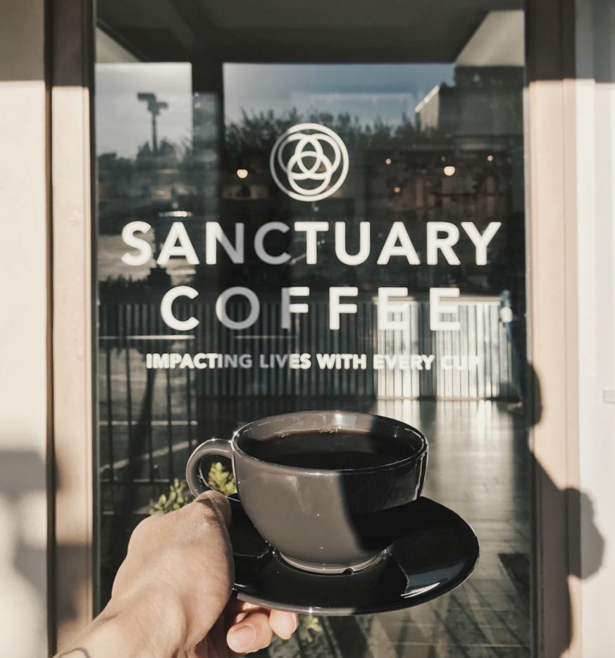

Executive Summary
Sanctuary Coffee, located in Claremont, California, is a 501c3 nonprofit organization founded by former University Dean and Professor, Dr. Steve Gerali along with some former students. The name of the location communicates to all of the visitors that it is both a safe and sacred place, similar to a sanctuary. Dr. Gerali has no desire for Sanctuary Coffee to be the next biggest coffee shop; he simply wants to focus on community enhancement. It started as a place to mentor individuals to help build character and get them inspired to give back. He did not like the fact that other companies lacked integrity as they promised to give back by using charity as a pity tactic to still make a profit. The idea of opening Sanctuary Coffee is just a front for what he intends to do, which is to advocate social justice. He is striving to make a positive impact in the surrounding communities of Claremont while building a community with individuals who share the same vision.
Situation Analysis

Internal
Are you meeting your current objectives? Sales and marketing
The exceeded their expectations of their sales goals. The have a 50,000 debt to personal finances which they will pay back, and afterwards want to hopefully open up another store in hopes to improve a community by offering volunteer work near that community. In the 9 months that they have been open, they have been completely exceeding their goals. They have to think faster about what their next move business wise is.
Do you have any internal organizational challenges that might be affecting your marketing efforts or success?
The store heavily relies on word of mouth. Students tell students and the customer becomes the hero by passing on the word.
The employees have bought into the vision of the business and are either former students of the owner or have a mentoring relationship with the owner. This helps the business. The only problem is that they have grown so quickly and don’t know where or how to grow. This could possibly mean cutting staff from many part time employees to a fewer amount of full time employees. They want to focus on making a profit but also give profits with integrity.

Customer
Who are your current customers? Who are your potential customers?
Their current primary customers consist largely of millenials. This includes current college students or young professionals. They benefit greatly by being near Cal Poly, La Verne, and Western. They also cross the generation divide by reaching the senior market in the morning and groups of high school students in the afternoon.
Where can your customers purchase your products?
They are trying to sell their coffee online, but shipping costs are very high. The cost of the coffee added to the cost of shipping becomes very expensive. Their bags of coffee are also available in store. They came up with a subscription strategy where you are able to pay a flat rate and receive a different coffee every month.
The time of day or year does not really affect the purchasing of coffee so far. The only time they dip in sales is sometime around meal times. Coffee takes a small dive around the summer, which is when they opened, but they did not experience any
Why might customers not purchase your products?

External
Who do you consider your competition?
Sanctuary Coffee is considered by other coffee shops as the competition. They do not want to be considered as a competitor, because they want all businesses to succeed. They even tell customers about other coffee shops and offer tips on how they taste differently. They want to impact other businesses in a good way and
Price wise, they are competitive, but a little lower than some other coffee shops. They have to take their prices in consideration because of minimum wage and other factors, in order to keep their profit margin at a break even point. They want to also prove that they are not about making the most money.
How much have you grown as a business since you began?
They have grown so much as a business that it is hard for them to chart and track. They started with one third of the inventory that they have now, and have also grown into their coffee suppliers largest client. They currently employ a staff of fifthteen baristas.
Was your business affected by any economic activities such as employment rate or taxes?
Is your business affected by technological advancements?
In the coffee industry, there are many upcoming technological advancements. One of their board members is the executive vp of a coffee company Automated machines and Nitro taps are the next best things. They just received new automations in cold brewing. In the coffee business, people aren't looking so much at the technology, but the quality.
POS wise, it is very costly to update their systems. These machines take up a lot of their sales profits, but make
Nitro- this summer

SWOT

Strengths

Weaknesses

Opportunities

Threats
With such opportunities, Sanctuary Coffee as well faces different threats. One of the biggest threats is stiff competition from numerous coffee shops in the market that try to copy-cat the company’s brand. Another threat is that the coffee market may shrink in future due to the invention of another type of leisure activity or beverage to replace coffee in the near future. This may force Sanctuary Coffee to shut down.

TOWS Matrix

Developing competitive advantage

Marketing Goals and Objectives
The marketing goal and objective of Sanctuary Coffee is to impact lives. They want to inspire others to give back to the community as well as advocate social justice. Being a nonprofit organization, all of their profits go towards charities located in Claremont and surrounding communities that are in need. Sanctuary Coffee is just a front for their mission. It is not only about the amount of sales they get or how much they are profiting, but it is about making customers aware of community needs that they were not aware of before and have them be a part of the movement.
Marketing strategy and Marketing mix
Primary Target Market: The primary target market for Sanctuary Coffee are millennials, specifically current college students and young professionals in their 20’s. There are a few college campuses located within ten miles from Sanctuary Coffee including University of La Verne, The Claremont Colleges, Western University of Health Sciences, and Cal Poly Pomona. Students are usually looking for a place to study, especially when it is midterm or finals week. Sanctuary Coffee provides a spacious seating area and a relaxing atmosphere to their customers as a large segment of their customers are students. Though Sanctuary Coffee primarily targets millennials, they have a wide range of customers throughout the day varying from students from surrounding high schools to elderlies from nearby senior citizen villages.
Product: Sanctuary Coffee consist of a simple product portfolio and a deep product line.

Product Line | Product Mix
Product Line | Coffee Classics | Specialty Coffee | Specialty Drinks | Coffee Beans
Product Line | - Fresh Brew  - Espresso  - Macchiato  - Cappuccino  - Americano  - Cafe Latte  - Cold Brew  - Artisan Tea | - Flavored Latte  - Creme Brûlée Latte  - Cinnamon Mocha Latte  - Caramel Turtle Latte  - Coconut Almond Latte | - Chai Tea Latte  - Dirty Chai  - Green Tea Mint Latte  - Hot Chocolate  - Shot in the Dark  - Tonic Water | - Brazil: Mogiana Peaberry  - Colombia: La Esperanza  - Ethiopia: Wenago  - Espresso: Flight of Fancy  - Guatemala: El Rincon  - Sumatra: Tano Batak  - Espresso: Decaf  - Decaf: Brazil

Price: Sanctuary Coffee sets the price for their products a little lower than other coffee shops. The coffee is at an affordable price for their target market that is predominantly millennials. All of the coffee classics, specialty coffee, and specialty drinks range from $1.75 to $4.95, regular or large size, and the coffee beans range from $12.95 to $15.95 for a 12 ounce bag.
Distribution/Supply Chain Strategy: One of their social justice concern is to ensure that coffee farmers receive an ethical wage. Sanctuary Coffee only deals with coffee beans that are fair or direct trade. The roaster that they work closely with is located in Redlands, California. Sanctuary Coffee has a small supply chain because they do not have a high demand compared to chain coffee shops. A small supply chain allows them to efficiently keep track of inventory, while reducing costs and increasing output. Currently, they are trying to break out of the coffee shop of distribution and sell coffee beans on their website. The problem with online distribution is the shipping cost. With the shipping cost included, the product becomes more expensive and out of the price range. But, they are planning to launch a subscription strategy in which customers can pay a flat rate and they will be sent a different bag of coffee every month.
Promotion Strategy: Sanctuary Coffee is heavily reliant on word of mouth as a way to promote their products and increase awareness of social issues. People are able to quickly spread the word and recommend others to support the cause. Aside from word of mouth, they use social media platforms, Instagram, Facebook, and Twitter to communicate with their followers and keep them updated with current promotions. Their most recent promotional campaign was done at Cal Poly Pomona. It was a 2 for 1 promotion in which students can buy a cup of coffee and get one free to share. They are planning to launch student discounts as early as next month to encourage more college students to visit and help impact lives with every cup. Moreover, they have been implementing a stamp card loyalty program. The stamp cards are stamped per visit and after 10 stamps, anything from the menu could be redeemed for free. Each stamp is initialed by the barista and if the same barista initials four times in a row and does not recognize the customer by name, the barista has to buy the customer a cup of coffee. Customers can potentially get 3 free drinks out of 1 stamp card and it is a way for them to foster and maintain customer relationships.
Public Relation Strategy: Sanctuary Coffee is a nonprofit coffee shop whose goal is to impact lives by supporting local communities. They network with community leaders, pastors, clergy, civil leaders, police department, fire department, and business leaders. The coffee house will turn all of its profits into Claremont and the surrounding communities. “One-hundred percent of our profits goes to charities within this community”, said owner Dr. Steve Gerali. “Plus our coffee roaster donates 10 pounds of food for every pound of coffee that we sell”. The business also guarantees that the coffee and tea it sells comes from farmers who are paid fair wages. Steve Gerali hopes a little extra love in each cup will add up to one big donation at the end of the year for families in Claremont.

Consultation to the business owner/manager (14 points)
As a group, we found that the concept of Sanctuary Coffee is what attracts customers and differentiates them from other coffee shops. Sanctuary Coffee is continuously growing since they opened less than a year ago and their success is a result of their marketing strategy and implementation. As college students, their primary target market, we drink coffee on a daily basis. The consumption of coffee among all ages has increased over the years and after looking at the trends, there has been a significant increase of coffee consumption in the younger generation. Moreover, because students are constantly looking for places to study… One of the recommendations that we have is to be more active on social media. Millenials are always on social media and to increase awareness of not only the coffee shop, but also the cause, postings should be done more frequently at least twice a week.
- Needs more space, already considering a second location
- Create a online thread, where people can talk about their ideas with each other
- Endless coffee
- Stamp card idea, if the barista doesn't know your name by x number of times they buy you a drink

Source of Information

Bulletin, T. I. (2017, June 04). How a Claremont shop is using coffee as a vehicle for change. Retrieved March 02, 2018, from https://www.dailybulletin.com/2017/06/04/how-a-claremont-shop-is-using-coffee-as-a-vehicle-for-change/

Novilla, M. (2017, October 06). Non-profit coffee shop donates to the homeless. Retrieved March 03, 2018, from https://lvcampustimes.org/2017/10/non-profit-coffee-shop-donates-to-the-homeless/

Rhodes, M. (2017, June 12). From academia to nonprofit, creating a unique sanctuary. Retrieved March 03, 2018, from https://www.claremont-courier.com/articles/news/t23608-coffee

Biggest challenge: He thinks strategic. EX: cold brew, wait until summer because that's when it will make them the most money. It is hard to hold out on things like this.

Stand out: Only shop in claremont that only does artisan coffee. Tried sandwiches, but don't want to expand like that. In n out mentality. “Do one thing and do it well.

Challenge: to only sell artisan coffee while people have faster pace lives. They want a place where people feel like they belong and get what they want.

HS student that wants to create an app to pre order very soon.
Customers keep coming because of the cost- it doesn't have to be good, it's just the cost is so good so i'll buy it. It ended up being good as well.

Their customers are more important than their product. We are the tenth group to come interview them from a school. Community center more than a coffee shop.

Greatest threat: price gouging. They pay a lot in taxes, such as equipment tax, even as a nonprofit to the government. The high cost of insurance is also a big threat, employees and board included.

Their business would not be as successful as it is today if it wasn’t a non profit. They didn’t have to pay for fees such as public health or business fees to the city. Those fees are based on the value that they bring to the city. They have only brought in about half of a million dollars since they have been open.

They chose claremont to establish their business because he used to meet up with students as a mentor and it they found it hard to bounce between different restaurants and have a conversation and feel comfortable. They are also 1, 2, and 3 miles away from 3 colleges. They did not establish in Pomona because they didn't find a large enough coffee clientele. They understand pomona needs their help, so they can also offer their services thier.

They want to really focus on marketing to Cal Poly Pomona. We, as students, believe that this location is further from our campus, but the area in the shop is much more comfortable.

Implementing student discounts with your student ID.

Offer stamp cards and they are stamped per visit. There is no restriction for the 11th free coffee.
The barista initials the stamp card,

Three recipients of their community service:

Ability first. They work with people with developmental disabilities

Inland Hope Partners- work with homeless and food pantries, staff them and provide transitional housing for help families in need. Become recipients of food and monetary donation

Everyone Free- working with sex and human trafficking within the I 10 corridor, which includes Pomona and Claremont.

Healing social concerns: really focusing on families that are healing with disabilities. They are trying to stay as humble as they have been since they opened. They were glad to prove to the skeptics that didn’t think their business model could work out.

